REVISED INTERVIEW PROGRAMME FOR THE MONTH OF AUGUST, 2015.

In continuation of Interview Programme for the month of August, 2015 issued vide No. 4316 dated 06-07-2015, the interview schedule have been revised / rescheduled as under, due to withdrawal of the posts for Nowshera Medical College by the Government.

AUGUST, 2015 |  |  |  |  | Time | No. of Post(s) | Nomenclature of Post(s) | Advt. No. | Candidates | Dealing Suptt.
M | T | W | TH | F
17 | 18 | 19 | 20 | 21 | 09:00 | 226 | Female Charge Nurses in Health Department. (BPS-16) | 01/2015  S.No.53 | 10 daily  06 on Friday  Total = 882 | Tanveer Musharraf
24 | 25 | 26 | 27 | 28
31 | - | - | - | -
( Continued )

The interviews of Gajju Khan Medical College, Swabi, already scheduled on 3rd and 12th August, 2015 will remain intact.

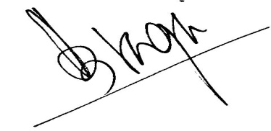
DIRECTOR RECRUITMENT

